Complete CI/CD Pipeline Using GitHub, Jenkins, Docker, and EC2

Introduction
Continuous Integration and Continuous Deployment (CI/CD) is a modern software development practice that automates the process of building, testing, and deploying applications.
In this project, a complete CI/CD pipeline was implemented using:
- GitHub
- Jenkins
- Docker
- Amazon Web Services EC2
The pipeline automatically deploys website updates whenever code is pushed to GitHub.

Project Architecture

CI/CD Workflow Architecture
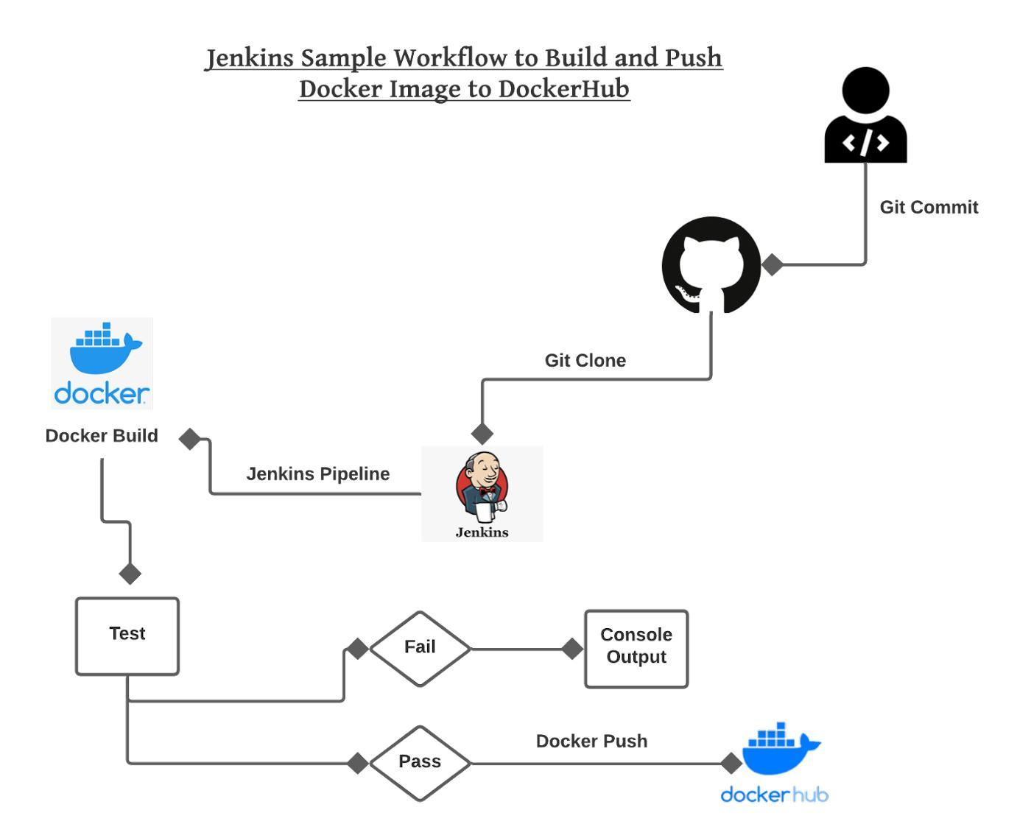
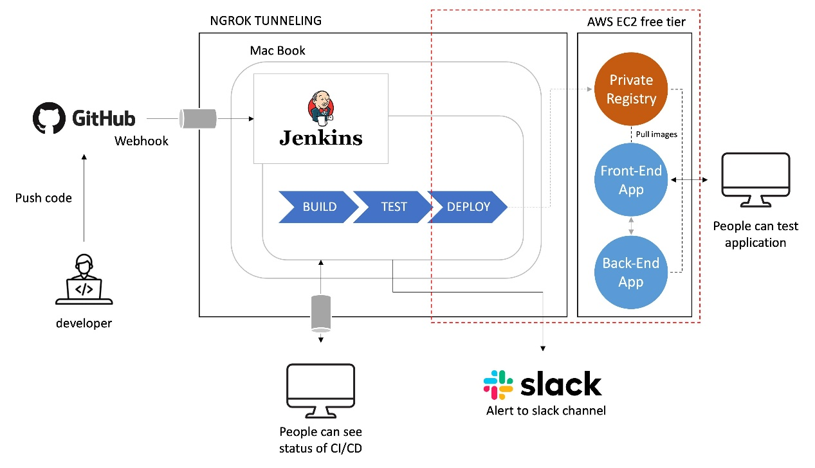

Architecture Flow
Developer
↓
GitHub Repository
(Webhook Trigger)
↓
Jenkins Server (EC2)
↓
Build Docker Image
↓
Stop Old Container
↓
Run New Container
↓
Website Live on Port 9090

Technologies Used
Technology | Purpose
GitHub | Source code management
Jenkins | CI/CD automation
Docker | Containerization
Amazon Web Services EC2 | Cloud server hosting
Nginx | Web server

Step 1 — Launch AWS EC2 Instance

Create EC2 Instance
Launch an Ubuntu EC2 instance from AWS Console.
Recommended configuration:
Setting | Value
OS | Ubuntu Server 24.04
Instance Type | t2.micro
Storage | 20 GB
Security Group | Allow 22, 8080, 9090

Configure Security Group
Open these ports:
Port | Purpose
22 | SSH
8080 | Jenkins
9090 | Website

Step 2 — Install Docker

Update Packages
sudo apt update

Install Docker
sudo apt install docker.io -y

Start Docker

sudo systemctl start docker
sudo systemctl enable docker

Add Jenkins User to Docker Group

sudo usermod -aG docker jenkins
sudo usermod -aG docker ubuntu

Step 3 — Install Jenkins

Install Java
sudo apt install openjdk-17-jdk -y

Add Jenkins Repository
curl -fsSL https://pkg.jenkins.io/debian-stable/jenkins.io-2023.key | sudo tee \
/usr/share/keyrings/jenkins-keyring.asc > /dev/null
echo deb [signed-by=/usr/share/keyrings/jenkins-keyring.asc] \
https://pkg.jenkins.io/debian-stable binary/ | sudo tee \
/etc/apt/sources.list.d/jenkins.list > /dev/null

Install Jenkins
sudo apt update
sudo apt install jenkins -y

Start Jenkins
sudo systemctl start jenkins
sudo systemctl enable jenkins

Access Jenkins
Open browser:
http://EC2-PUBLIC-IP:8080
Example:
http://51.20.91.105:8080

Unlock Jenkins
Get initial password:
sudo cat /var/lib/jenkins/secrets/initialAdminPassword
Paste password into Jenkins UI.

Install Jenkins Plugins
Install recommended plugins.
Important plugins:
- Git Plugin
- GitHub Integration Plugin
- Pipeline Plugin
- Docker Pipeline Plugin

Step 4 — Create GitHub Repository

Create Repository
Example repository: . it should contain your code to be displayed
GitHub RepositoryStep 5 — Create Dockerfile

Dockerfile: Create a file name “Dockerfile” inside the repot and insert the below code
FROM nginx:alpine

COPY . /usr/share/nginx/html

EXPOSE 80

Explanation:

- FROM nginx:alpine : Uses lightweight Nginx image.
- COPY . /usr/share/nginx/html Copies website files into Nginx web directory.
- EXPOSE 80 Exposes web server port inside container.

Step 6 — Create Jenkinsfile

Jenkins Pipeline Script
Create a file name “Jenkinsfile” inside the repot and insert the below code
pipeline {
agent any

stages {

stage('Checkout') {
steps {
git 'https://github.com/Aswinvtk/aswinvtk.github.io.git'
}
}

stage('Build Docker Image') {
steps {
sh 'docker build -t aswinvtk/github-pages-site .'
}
}

stage('Stop Old Container') {
steps {
sh 'docker rm -f github-pages-site || true'
}
}

stage('Run Container') {
steps {
sh '''
docker run -d \
--name github-pages-site \
-p 9090:80 \
aswinvtk/github-pages-site
'''
}
}
}
}

Jenkins Pipeline Explanation
git 'repository-url' Clones latest code from GitHub.

docker build -t image-name .Creates Docker image from Dockerfile.

docker rm -f container-nameRemoves existing running container.

docker run -d -p 9090:80 Starts new container.Port mapping:
EC2 Port | Container Port
9090 | 80

Step 7 — Create Jenkins Pipeline Job

Create New Item
In Jenkins:
New Item → Pipeline
Job name:
bio

Configure Pipeline
Under Pipeline:
Select:
Pipeline script from SCM
SCM:
Git
Repository URL:
https://github.com/Aswinvtk/aswinvtk.github.io.git
Branch:
*/main
Script Path:
Jenkinsfile

Step 8 — Configure GitHub Webhook

GitHub Webhook Settings
Go to:
Repository → Settings → Webhooks
Add webhook.

Payload URL
http://51.20.91.105:8080/github-webhook/

Content Type
application/json

Event
Just the push event

Step 9 — Enable Jenkins Build Trigger
Inside Jenkins Job:
Configure → Build Triggers
Enable:
GitHub hook trigger for GITScm polling
This automatically triggers builds after GitHub push.

Step 10 — Push Code to GitHub

Git Commands
git add .
git commit -m "Updated website"
git push origin main

Step 14 — Jenkins Build Process

Jenkins Automatically:
- Receives webhook
- Pulls latest code
- Builds Docker image
- Stops old container
- Deploys new container

Jenkins Console Output

Successful Build console Output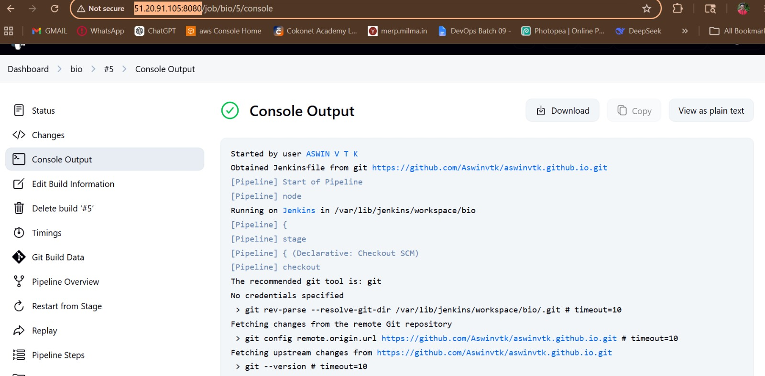

Example console log:
Started by GitHub push

[Pipeline] stage
[Pipeline] { (Build Docker Image)

+ docker build -t aswinvtk/github-pages-site .

Successfully built 7f47c6938817
Successfully tagged aswinvtk/github-pages-site:latest

[Pipeline] stage
[Pipeline] { (Run Container)

+ docker run -d --name github-pages-site -p 9090:80

Finished: SUCCESS

Docker Image Verification

Check Images
docker images
Output:
REPOSITORY TAG IMAGE ID
aswinvtk/github-pages-site latest 7f47c6938817
nginx alpine 2f07d83bf561

Running Container Verification

Check Running Containers
docker ps
Output:
CONTAINER ID IMAGE PORTS
ea50f8ccbaea aswinvtk/github-pages-site 0.0.0.0:9090->80/tcp

Access Website
Open browser:
http://51.20.91.105:9090

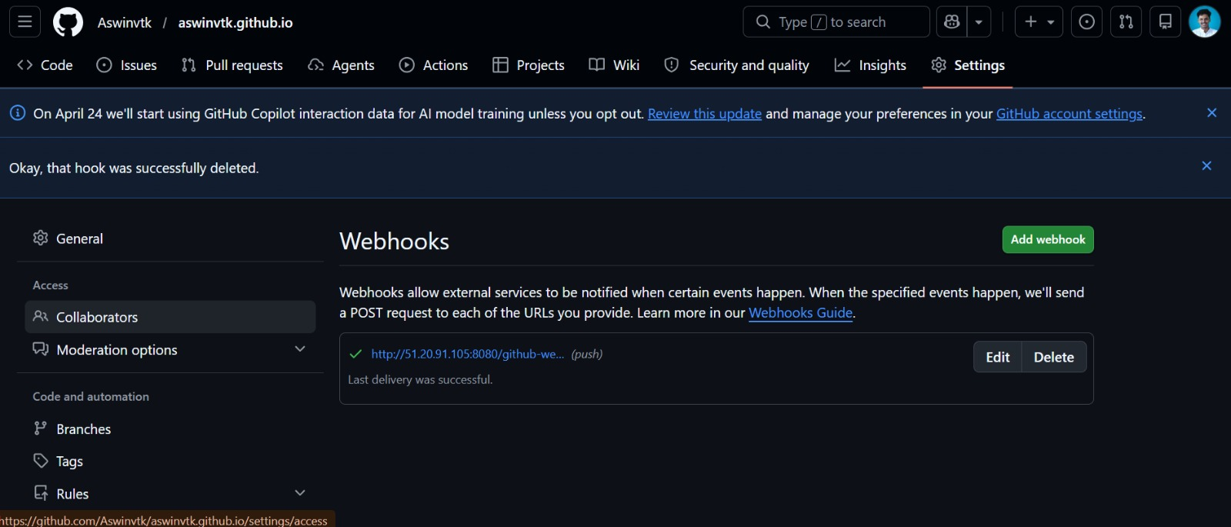
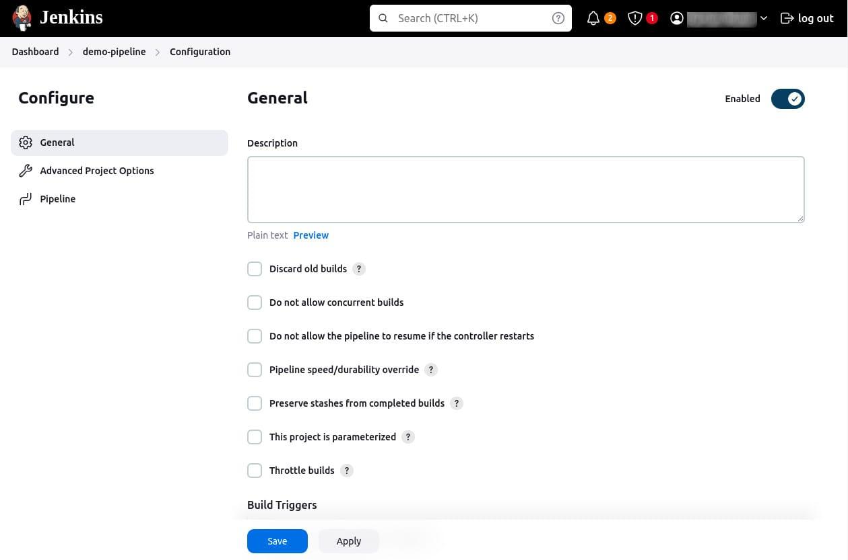
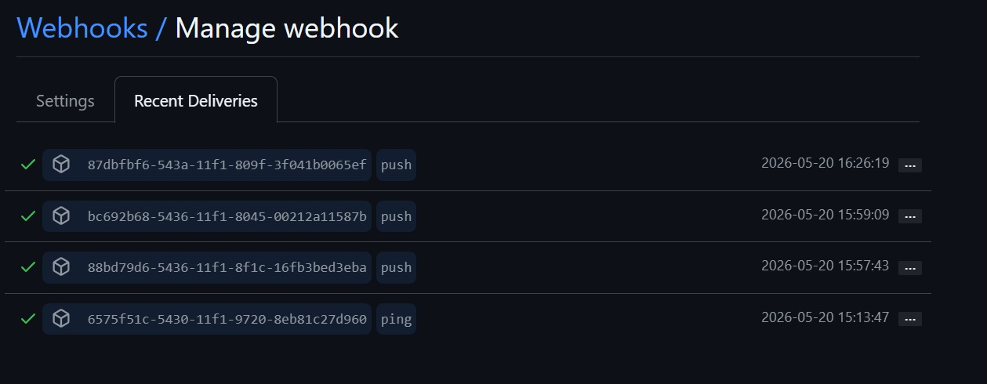

Challenges Faced

Common Issues
Problem | Solution
Docker permission denied | Add Jenkins user to docker group
Webhook not triggering | Enable GitHub hook trigger
Port inaccessible | Open EC2 security group ports
Jenkins build fails | Verify Docker service

Conclusion
- A CI/CD pipeline was implemented using GitHub, Jenkins, Docker, and AWS EC2.
- First, an EC2 Ubuntu server was created and required tools such as Java, Jenkins, Docker, and Git were installed.
- The website source code, along with the Dockerfile and Jenkinsfile, was uploaded to a GitHub repository.
- Jenkins was then connected to the GitHub repository using a pipeline job.
- A GitHub webhook was configured to automatically trigger Jenkins whenever code was pushed to the repository.
- After each push, Jenkins automatically pulled the latest code, built a Docker image, removed the old container, and deployed a new container on the EC2 server.
- This enabled automatic deployment of the updated website without manual intervention, achieving a complete CI/CD workflow.
This project successfully implemented a fully automated CI/CD pipeline using:
- GitHub
- Jenkins
- Docker
- Amazon Web Services EC2
The pipeline automatically deploys website updates whenever code is pushed to GitHub, reducing manual effort and improving deployment speed and reliability.
This architecture demonstrates a practical DevOps implementation suitable for modern web application deployment.

